Minor Project
🧩 Project 1: Linux IAM & Hardening mini (Users, Groups, Permissions)
Objective:
Linux IAM & Hardening mini (Users, Groups, Permissions) Objective: Design and implement a secure user/group and permission model on an Ubuntu server, find 3 misconfigurations in a deliberately vulnerable lab VM, f ix them, and produce a remediation report.
Tools / Environment:
Ubuntu VM (lab), Kali or attacker VM for safe testing, sudo access to lab VM.
Tasks:
Task 1: Policy + create users/groups + set permissions, enable auditing.
Task 2: Vulnerable snapshot analysis, fix issues, produce report + checklist.

Task 1: Policy + create users/groups + set permissions, enable auditing.
Create a baseline policy document: who needs sudo, group roles, and file access requirements for a small team (e.g., admin, dev, auditor).
On an Ubuntu VM, create users and groups according to the policy (use useradd, groupadd).
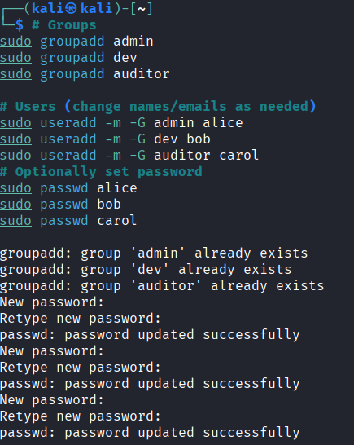

Assign minimal privileges: configure sudoers using any text editor with least-privilege rules, set sudo rules for specific commands only.
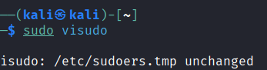

Use POSIX permissions + ACLs for a shared project folder so that only the intended group has write access; others have read-only.
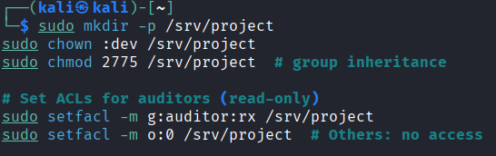

Enable simple auditing (auditd) to log changes to /etc/sudoers and /etc/passwd.
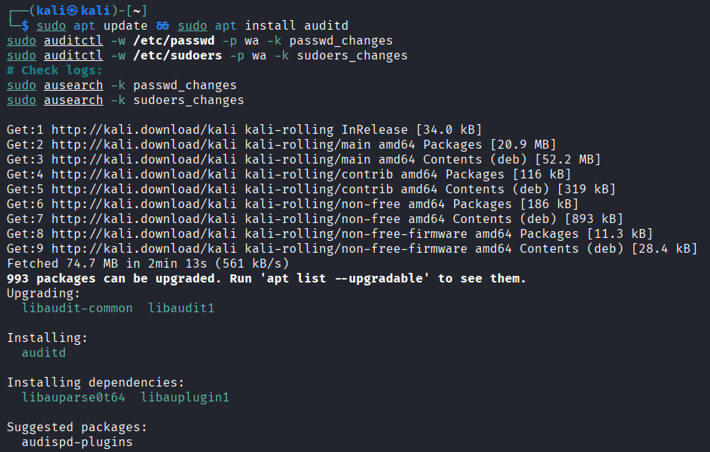
In a separate vulnerable snapshot (instructor provides or students intentionally misconfigure), identify three misconfigurations (e.g., world-writable /etc/cron.d, unrestricted sudo NOPASSWD, weak file permissions on sensitive files).
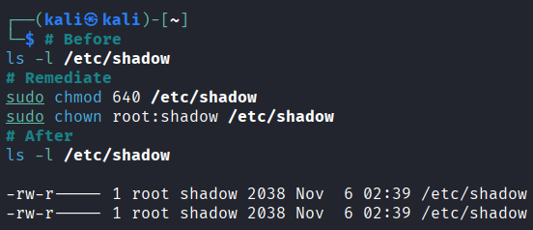
Task 2: Vulnerable snapshot analysis, fix issues, produce report + checklist.
Fix those misconfigurations, document steps, and show before/after evidence (ls -l, getfacl, audit logs).
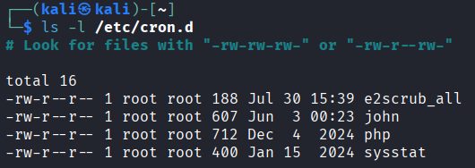

Produce a remediation checklist and a short policy document for ongoing user management.
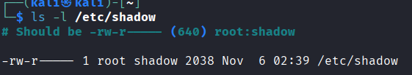

Evidence (screenshots or text) showing misconfiguration discovery & fixes.
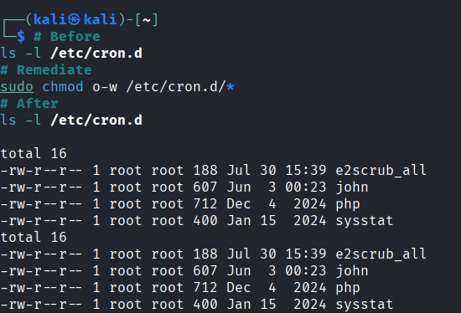

Audit logs snippet showing tracked changes.

Remediation checklist.
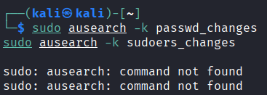

SUMMARY
Skills & Learning Outcomes:
• Linux user and group administration
•Principle of least privilege
• Secure sudo configuration
• File permission and ACL management
• Basic auditing and incident tracking
• Vulnerability detection and remediation documentation.

In short: You build a secure access control model on Linux, identify and fix intentional security flaws, and document how to maintain a hardened, auditable

